PATENT QUOTATION
Dated: 19/03/2024
Addressed to:
I-HUB for Robotics and Autonomous
Systems Innovation Foundation,
ARTPARK, INDIAN INSTITUTE OF SCIENCE,
Ground Floor, Entrepreneurship Bldg,
near High Voltage engineering,
Bengaluru, Karnataka 560012
Quotation Prepared by:
Adv. Pranav Bhat
Contact Details:
9035685434
Email: an.astraea@gmail.com / pranavbhat334@gmail.com

Sl. No | Particulars | Cost (Govt Fee + Prof Fee + Misc.)  For Individual/Startup/Small Entity/Educational Institution | Cost (Govt Fee + Prof Fee + Misc.)  For large entity
1.a | Patent searching with oral opinion, Provisional specification drafting and filing | 1,600+12,000+650 = 14,250/- | 8,000+12,000+650 = 20,650/-
1.b | Complete specification drafting after provisional, filing and request for early publication and Examination | 6,500+23,000+0 = 29,500/- | 32,500+23,000+0 = 55,500/-
2. | Patent searching with oral opinion, Direct complete specification drafting, filing and request for early publication and Examination | 8,100+33,400+650 = 42,150/- | 40,500+33,400+650 = 74,550/-
3. | Response to Examination | 0+25,000+0 = 25,000/- | 0+25,000+0 = 25,000/-
4. | Attending hearing and filing written submission | 0+33,000+0= 33,000/- | 0+33,000+0= 33,000/-
Notes:
- Additional 18% GST applicable on professional fee
- The payment shall be made in stages, if there is no hearing then it shall not be charged. If there is any other cost involved, quotation shall be shared prior.
- Additional government fee shall be payable if instructed by the applicant for performing any formality at the patent office apart from procedure above mentioned or if directed by the patent office during the examination.
- If permission from the NBA or any other separate official compliances is required, fee for the same shall be quoted separately.
- Stamp paper, notary expenses, and courier charges will be applicable from case-to-case basis.
- Any additional reimbursements, if applicable, will be informed to you priorly for your approval before proceeding.
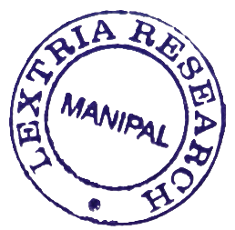
Should you have any questions or require further clarification, please feel free to contact us at the provided email or phone number. Thank you for considering our services. We look forward to assisting you with your intellectual property needs.
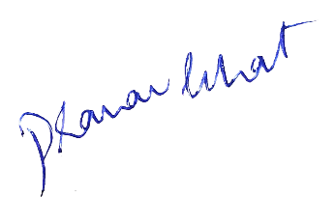

Best Regards,
Adv. Pranav Bhat
Chief IP Strategist
Lextria Research
(Formerly known as Astraea Research)

